HILLY FIELDS FOOTBALL CLUB
SEASON 22: 1988-89
FIRST TEAM:
BECKENHAM & CATFORD ALLIANCE:
P W D L F A Pts Pos
Division 1 13 10 1 2 48 28 21
Beckenham League Cup 3 2 0 1 11 9
Beckenham Hospital Cup 1 0 0 1 0 1
Peter Bowden Invitation 3 2 0 1 6 7
Friendly 5 4 0 1 18 6
TOTAL 25 18 1 6 83 51

Apps Gls Apps Gls
Dean Chatfield 21 29 Kevin McCormick 23 0
Mick Chatfield 16 0 Mark Rumbelow 25 0
John Coles 3 0 Nick Runbelow 25 2
Peter Covington 7 2 Costas Salacuri 4 0
John Felton 1 0 Tommy Salacuri 24 18
Jim Flood 24 3 Kevin Shearer 22 6
Steve Ford 24 7 Charlie Shoppee 13 1
Len Franklin 3 0 Mark Thompson 17 0
Tony Gallifant 1 0 John Wood 23 5
Larry Garnham 2 0 Chris Yusuf 14 2
Dave Keay 21 2 OG 6
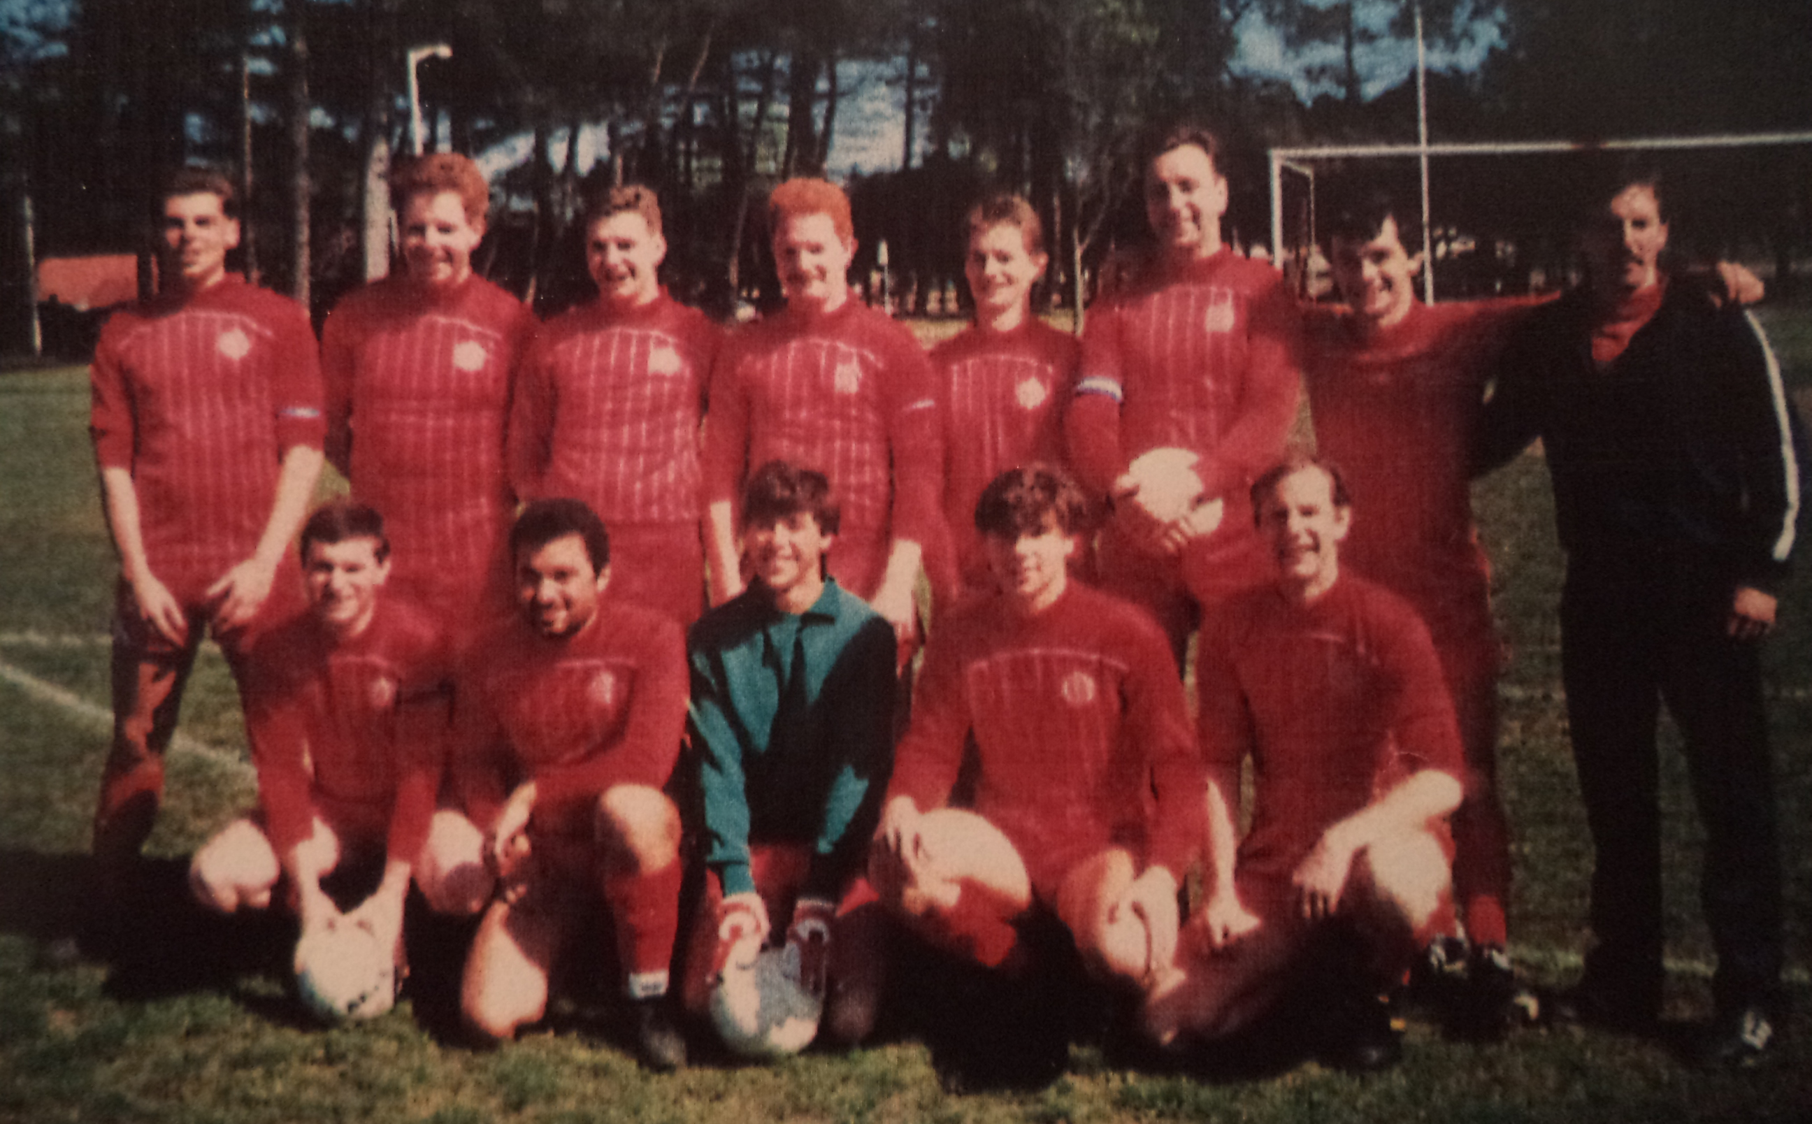
L-R Back: Mark Rumbelow, Dave Keay, Peter Covington, Jim Flood, Steve Ford, John Wood, Dean Chatfield, Charlie Shoppee L-R Front: Mick Chatfield, Tommy Salacuri, Mark Thompson, Nick Rumbelow, Keith Foster

